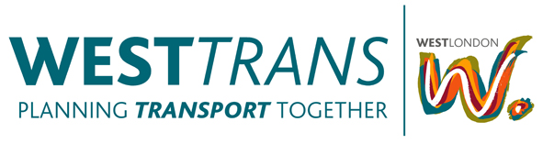
Date: Thursday 21st March 2013, 2.00pm-3.30pm
Location: Ealing Town Hall, Nelson Room

Chair: Tim Forrester, WestTrans

Agenda
- Apologies
- Notes of Last Meeting/Matters Arising
- WestTrans Work Programme update (written update provided)

Key points:
  - 2012/13 budget review
  - Strategic Cycling Study project update (Mayors Vision)
  - Priorities for 2013/14
  - WestTrans funding allocations for 2013/14 (inc. MO post)
- Finn Coyle - Environmental Manager (Transport Emissions) TfL
- Mayors Air Quality Fund discussion
- Lucy Saunders – Public Health Specialist (GLA/TfL)
- Any Other Business
  - European Cycle Challenge
  - WLB Transport Group
- Date of Next Meetings

Scheduled to take place on:
- Thursday 16th May 2013 @ 2.00pm – Ealing Town Hall, Nelson Room
- Thursday 25th July 2013 @ 2.00pm – Ealing Town Hall, Nelson Room
- Thursday 20th Sept 2013 @ 2.00pm – Ealing Town Hall, Nelson Room
- Thursday 29th Nov 2013 @ 2.00pm – Ealing Town Hall, Nelson Room
- Thursday 23rd Jan 2014 @ 2.00pm – Ealing Town Hall, Nelson Room
- Thursday 20th March 2014 @ 2.00pm – Ealing Town Hall, Nelson Room

